Effective use of learning software to improve learning and teaching, enhance self-assessment and use of College VLE.

Liza Field
May 2008
Proposal

My husband and I run a number of popular websites. With the original sites, launched in 2000, we rapidly found that interactive content was the most important. Flash-based learning games have been extremely popular.

Traditionally it has been difficult and time consuming to develop Flash activities. However we have developed tools which remove the complexity and allow any teacher, regardless of technical expertise, to generate their own customised versions. They enter the questions and details, press ‘generate’ and the content is instantly produced. It is a very user-friendly system with over 11 different programs.
  Add content |   Press generate |   .swf file produced

I have already agreed to give free copies of all the programs to the College, but following some careful thought I actually think we could make extremely productive use of some of the new features that have been recently developed. The concept fits directly with my lead teacher responsibilities to raise teaching & learning across the College and promote successful CPD.
See the ContentGenerator.net website for the specific details of the various learning activities.
I propose two tranches to my work:
Basic level
Use ContentGenerator.net learning games across the curriculum.
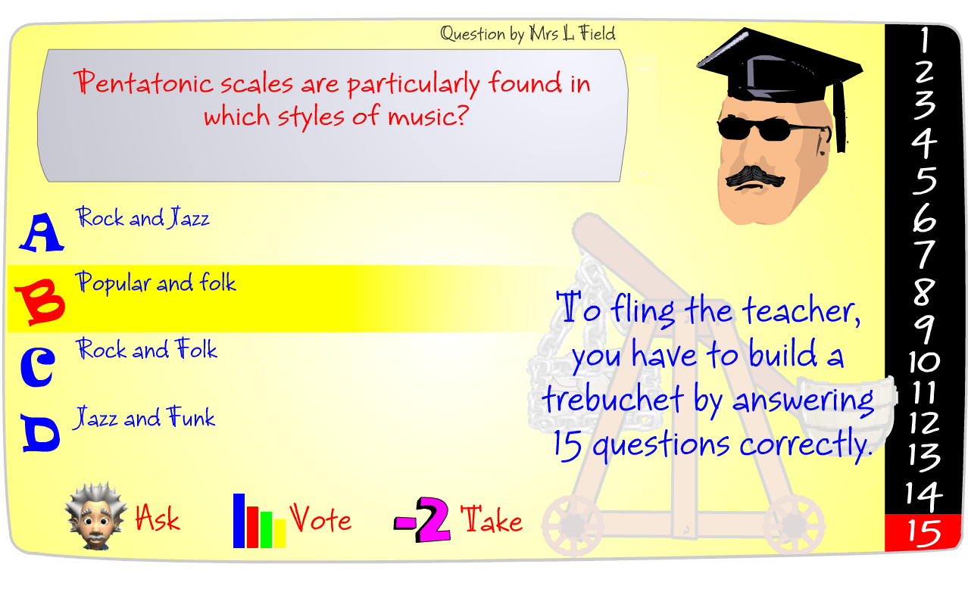
These programs allow teachers and students to generate their own Flash based interactive learning content for use on interactive whiteboards, via projectors, College network and website.
How?
Training session + online demonstrations that show staff ‘on demand’ how to use the software
Why?
Focus on the pedagogical benefits and possibilities rather than just ‘how to use it’ or ‘use it because it grabs their attention’.
Success criteria:
A teacher from each subject area experiments with the software with their classes in the second half of the summer term 2008, evaluating it for further use.

More advanced
Use the SCORM functionality to track student scores via Moodle
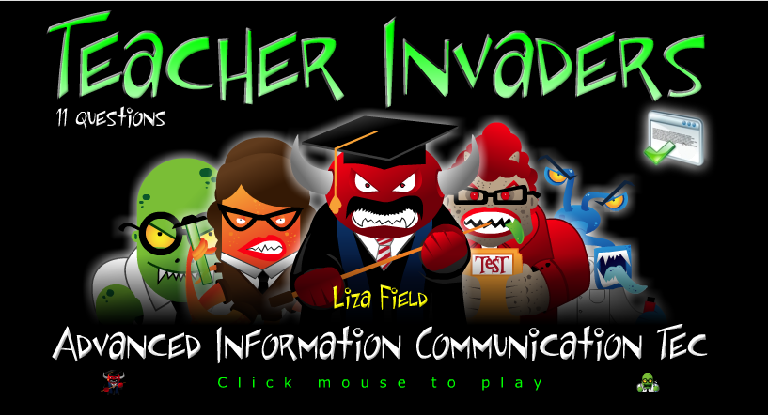
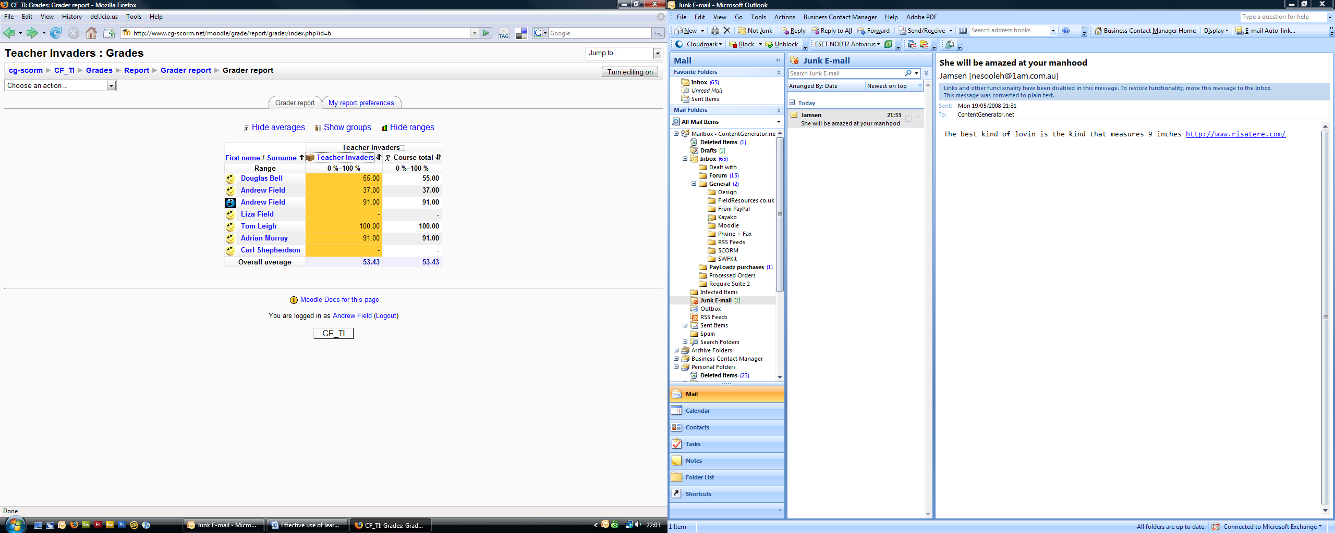

[continued from previous page]
This would be an extremely effective technique to enhance the whole school use of Moodle in a student-friendly and engaging way. Students can be set a teacher-created game or activity to complete outside of the standard classroom. Their scores – and usage – can be tracked using Moodle.
How?
Additional Training session together with documentation and online video demonstrations that show staff ‘on demand’ how to extend the use of the software
Why?
Rather than just using the games, quizzes and activities, we can actively track their usage using Moodle. For example, students could be set a Penalty Shootout game for homework. They log into the College Moodle site and attempt to get all the questions correct. Their highest score is recorded in the Moodle gradebook – this means we can set trackable homework and activities. A very powerful feature with lots of further potential in terms of learning and teaching.
Success criteria:
Usage records within the Soham Village College Moodle site. At least half of the subject areas within the College experiment with the software’s advanced capabilities .

Follow –up activities
- Student generated content
There is no reason the software is just used from the teacher’s perspective. An excellent use is to get students to generate their own games and activities for each other. It is a powerful revision and review activity anyway but its utility is raised even further if students are given full control.

- Self-assessment opportunities
Within Moodle the ‘MyMoodle’ functionality allows us to setup courses, deadlines and assessments for students when they login. It would be excellent to evaluate and develop this context further, allowing students to see their recent scores / assessments and then improve on their current standing.

- Focus on underachieving groups
Similarly, we could establish competitive league tables for certain learning games such as Penalty Shootout and HoopShoot. These are ideally suited to underachieving boys focusing on competition and reward for correct answers. The leagues could simply be printed out and pinned up, but a far more effective way would be to use our VLE to provide instantaneous feedback.



